SuperWoman

Software Requirements Specification

Version 1.0

Revision History

|  |  |  |  |
| --- | --- | --- | --- |
| **Date** | **Version** | **Description** | **Author** |
| 19.10.2017 | 1.0 | First Use Cases | Team SuperWoman |
|  |  |  |  |
|  |  |  |  |
|  |  |  |  |

Table of Contents

1. Introduction 3

1.1 Purpose 3

1.2 Scope 3

1.3 Definitions, Acronyms, and Abbreviations 3

1.4 References 3

1.5 Overview 3

2. Overall Description 3

3. Specific Requirements 3

3.1 Functionality 3

3.1.1 User-Management

3.2 Usability 3

3.2.1 <Usability Requirement One> 3

3.3 Reliability 3

3.3.1 <Reliability Requirement One> 3

3.4 Performance 3

3.4.1 <Performance Requirement One> 3

3.5 Supportability 3

3.5.1 <Supportability Requirement One> 3

3.6 Design Constraints 3

3.6.1 <Design Constraint One> 3

3.7 On-line User Documentation and Help System Requirements 3

3.8 Purchased Components 3

3.9 Interfaces 3

3.9.1 User Interfaces 3

3.9.2 Hardware Interfaces 3

3.9.3 Software Interfaces 3

3.9.4 Communications Interfaces 3

3.10 Licensing Requirements 3

3.11 Legal, Copyright, and Other Notices 3

3.12 Applicable Standards 3

4. Supporting Information 3

Software Requirements Specification

# Introduction

## Purpose

This SRS describes the functional and nonfunctional constraints of our project *SuperWoman*. The goal of our project is to provide a Jump’n’Run game on a website. We will implement different levels which will not only differ in the difficulty, but also on the task that the player has to fulfill. For example in some levels the player has to solve arithmetic problems and in others the user has to collect the fitting letters for a given word.

## Scope

The Software Engineering project *SuperWoman* offers the possibility to improve the user’s mathematical abilities and your power of concentration. Therefore it is targeted at students from primary and secondary school.

## Definitions, Acronyms, and Abbreviations

|  |  |
| --- | --- |
| SRS | Software Requirement Specification |
| UML | Unified Modeling Language |
| Vaadin | GUI-Framework based on Google Web Toolkit, which enables Java to make websites |
| MySQL | Database technology |

## References

|  |  |
| --- | --- |
| Blog | https://superwoman2017blog.wordpress.com/ |
| GitHub | https://github.com/ItalisaS/SuperWoman |
| Use Case Diagram |  |

## Overview

The next chapters contain a detailed description of our project and requirements.

# Overall Description

Our game will be web-based and will provide an opportunity to login, in order to save your progress and show a highscore. The following chapter represents our Overall User Case Diagram, which illustrated the features of our website.

## Use Case Diagram

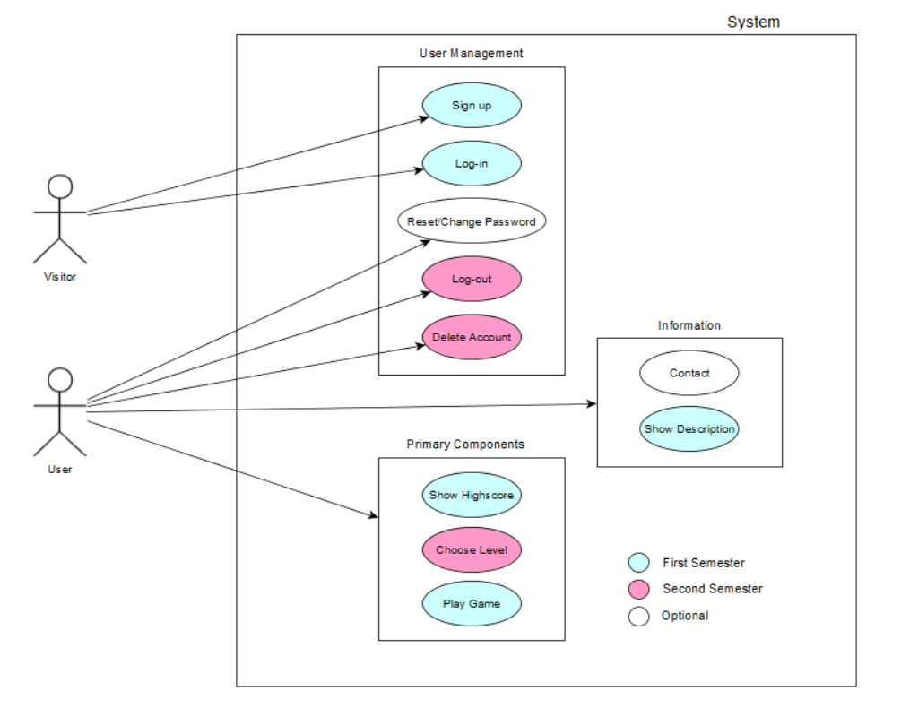

# Specific Requirements

## Functionality

### User-Management

This functionality includes all aspects concerning the management of the users and visitors. The visitor should be able to sign-up and create a new account. When a visitor is signed-up he has the possibility to log in into the website. Subsequently he has the right to reset or change the password or to delete his account.

### Information

The website has a contact page where the user has the opportunity to write a comment and submit a proposal for a new level-theme. For example, a teacher could propose a new level for his students suitable for the current topic of the lesson. After that we can decide if we will implement it or not.

Moreover, the user and the visitor can show a detailed description of the game.

### Primary Components

The user can choose between showing the highscore, choosing a level and starting the game.

## Usability

### User-Interface

The website should be easy to use and navigate.

## Reliability

### Server status

The server should always be running so that a user can play the game everytime he wants.

## Performance.

### Speed

It should be possible to play the game without interruptions in order that the entertainment is not restricted.

### Capacity

To be determined.

## Supportability

To be determined.

## Design Constraints

To be determined.

## On-line User Documentation and Help System Requirements

Not applicable.

## Purchased Components

Not applicable.

## Interfaces

To be determined.

### User Interfaces

### Hardware Interfaces

### Software Interfaces

### Communications Interfaces

## Licensing Requirements

Non applicable.

## Legal, Copyright, and Other Notices

Non applicable.

## Applicable Standards

Non applicable.

# Supporting Information